Deanna Harris
Deanna.harris@esc11.net
staff responsibilities
Role ID vs Service ID Matrix

ROLE-ID (E0721) identifies the capacity in which a person serves. Examples of roles are teacher, art therapist, and superintendent.

If a professional person's actual role is not found among the list of values for ROLE-ID in Code Table C021, choose the closest approximation to the actual role that is available in the table. It is possible that some professional and para-professional staff will also be reported with an Auxiliary Role ID on the StaffEducationOrgEmploymentAssociationExtension Complex Type. This is only true if the person is providing both professional/para-professional and non-professional auxiliary services. An example includes a classroom teacher who also drives a school bus route. There are some Role IDs on code table C021 that are either similar or identical to the Auxiliary Role IDs on code table C213. For these similar or identical roles, be sure that you are selecting only the roles that are applicable to the StaffResponsibilitiesExtension Complex Type.

ROLE-ID 033 - Instructional Educational Aides
Instructional Educational Aides are reported as role 033. Staff responsibility records are not reported for Non-Instructional Aides such as library clerks, office clerks, attendance clerks, health clerks, etc. In some instances, an instructional educational aide may serve in a library. A staff responsibility record is reported for aides who work in a library and spend most of their time helping students. Library clerks, who shelve books, check books in and out, and handle paperwork for the librarian are not reported on a staff responsibility record and are, therefore, considered auxiliary staff.

For further ROLE-ID guidance, see the following charts below:
When to Report ROLE-ID or/and AUXILIARY-ROLE-ID
Chart A: Coding for Substitute and Absent Regular Staff
Chart D: ROLE-ID vs. SERVICE-ID Matrix

SERVICE-ID (E0724) refers to the services supplied by staff.

The values for SERVICE-ID listed in Code Table C022 include both courses and non-teaching responsibilities. Responsibilities such as lunch monitoring duty or playground supervision are not included and, therefore, are not reported.

If the SERVICE-ID listed in Code Table C022 ends in XXX, then any value will be allowed in character positions 6-8. The values in character positions 6-8 will be changed to XXX at TEA during data loading.

For elementary classes, districts have the option of using either the generic elementary Service IDs (02010000 - Grade 1, 02020000 - Grade 2, 02030000 - Grade 3, 02040000 - Grade 4, 02050000 - Grade 5, 02060000 - Grade 6) for the core curriculum or the subject specific Service IDs in the student and teacher scheduling system(s). However, the district should make the decision to report these elementary Service IDs based upon what the students will be reported with on Course Completion data in the Summer submission. A school will not be able to report teachers using one method and students with the other as the data will not pass the fatal validation rules.

SERVICE-ID 02000000, Elementary, Grades 1-6, should be used only when a teacher is serving multi-grade or ungraded student populations, typically in a pullout program. It is not used for those situations where a district assigns a teacher two contiguous grades of students because neither grade has enough students to allow for a single classroom. Such teachers would have two StaffResponsibilitiesExtension complex types with different SERVICE-IDs and different CLASS-ID-NUMBERs.

SERVICE-ID SR000007, Unassigned professional instructional duty, is used only in two situations. See Chart A: Coding for Substitute and Absent Regular Staff.

For further SERVICE-ID guidance, see the following charts below:
Chart B: Local-Credit Courses
Chart C: P.E. and P.E. Equivalent Courses
Chart D: ROLE-ID vs. SERVICE-ID Matrix

The StaffResponsibilitiesExtension Complex Type inherits data elements from the StaffEducationOrgAssignmentAssociation Complex Type and contains data elements that are attributes of staff assignments.

StaffResponsibilitiesExtension Complex Type reflects the assignments for professional and paraprofessional staff only. Multiple records are required for persons who perform duties on more than one campus, assume more than one role, and/or perform more than one type of service. By definition, if no staff responsibility record is reported, the assumption is made that the person is an auxiliary staff member.

Staff responsibilities that occur before or after the normal school day for events where students do not receive credit are not reported (this includes but is not limited to sports practice, band practice, UIL clubs and practices). Staff responsibilities for courses taken for credit (including but not limited to zero-hour courses) and Adult Basic Ed classes are considered part of the normal school day for StaffResponsibilitiesExtension Complex Type reporting purposes. Therefore, courses that are offered to students before or after school for course credit must be reported with a StaffResponsibilitiesExtension Complex Type.

If an instructional professional performs more than one service in the same classroom setting, then each of those services are reported on an individual StaffResponsibilitiesExtension Complex Type. For example, there are not enough French foreign language students (French I, French II, and French III) to make up separate classes. If these classes are combined in the same classroom at the same time, then StaffResponsibilitiesExtension Complex Type will be reported for each SERVICE-ID (French I, French II, and French III).

Physical education, fine arts, and special education classes on elementary campuses may be reported using only one record or may be reported section by section, if desired.

Because of legislative requirements for class size reporting, districts are to report staff responsibility data at the lowest level possible. When the SERVICE-IDs for elementary courses are used for reporting the staff responsibility record on an elementary, junior high, middle school, or combined elementary/secondary campus, each section must be reported as a separate record.

Detailed schedules are not reported for Instructional Educational Aides (ROLE-ID 033) and certified interpreters (ROLE-ID 036). Instead, a StaffResponsibilitiesExtension Complex Type is submitted showing the total monthly minutes the staff person serves in that role. Generic aide and interpreter SERVICE-IDs are available for the record. NUMBER-STUDENTS-IN-CLASS should be reported as 0 for these roles. The number of students in the class should be reported on the teacher-of-record.

PEIMS Fall Submission (1):

The StaffResponsibilitiesExtension Complex Type is reported for the four weeks in October that include the PEIMS Fall snapshot date (last Friday in October). This is true for all professionals that were employed on the PEIMS Fall snapshot date (last Friday in October). The data elements that mExust be reported for each ROLE-ID are specified in the Staff Responsibility field validation rules.

If a school is closed for one or more days during the four weeks in October that include the PEIMS Fall snapshot date (last Friday in October), then the staff responsibilities, the services performed, and the minutes associated with those services, should be reported as if the school was in operation for each of the days.

If a district employs nine-week semesters (sometimes referred to as accelerated block schedules), report the data on the current semester only.

Each LEA must report a staff person identified as ROLE-ID 027 - Superintendent/Chief Administrative Officer/Chief Executive Officer/President. If an Assistant Superintendent or other administrative professional is serving as the superintendent due to the superintendent position being vacant, that person should be reported as the superintendent. This may result in that person having two different ROLE-IDs in the staff responsibility reporting.

All persons serving in professional roles in a LEA must be reported in Submission 1 with the appropriate ROLE-ID. For example, persons serving as teachers in the classroom on a campus must be reported with ROLE-ID 087 regardless of their employment arrangement with the LEA. It is necessary for each LEA to report all persons providing professional services to a LEA in order for TEA to compute and report the staff FTE data for the LEA.

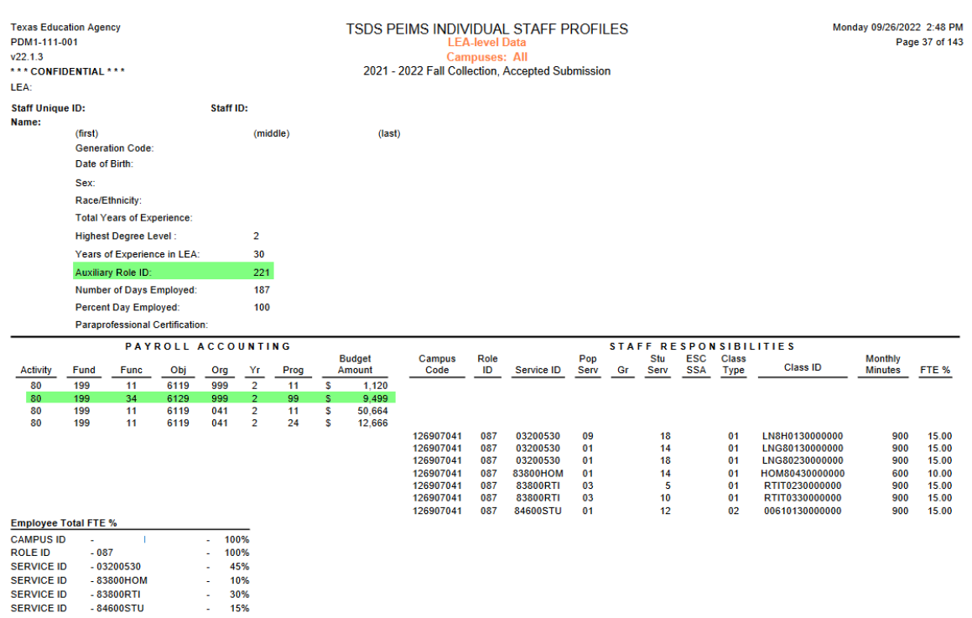

TWEDS - C021 Table

Role | Translation
 | PROFESSIONAL
002 | Art Therapist:  Serves as Art Therapist
003 | Assistant Principal:  Assists the principal of a particular campus in any duties the principal may deem appropriate
004 | Assistant/Associate/Deputy Superintendent:  Assists the superintendent of a particular school district in any duties the superintendent may deem appropriate. Persons assigned to this role usually perform functions associated with more than one campus
005 | Psychological Associate:  Serves under the Licensed Specialist in School Psychology (LSSP) or psychologist to provide guidance and counseling services to students
006 | Audiologist:  The person who provides audiological services to students with hearing impairments
007 | Corrective Therapist:  Serves as Corrective Therapist
008 | School Counselor:  Provides guidance and counseling services to students
011 | Educational Diagnostician:  Provides educational diagnostic services and individualized education program development
012 | District Instructional Program Director or Executive Director:  Serves under the superintendent, or higher grade instructional administrative officer, as the key specialist for a major instructional, instructional related, or pupil service program. Responsibilities may include curriculum development or supervision of programs or personnel whose assignments require certification or licensure. Only degreed, certified personnel may be placed in this category. Examples include, but are not limited to staff serving as Director of Guidance and Counseling, Director of Curriculum, Director of Librarians, Director of Bilingual/ESL, Career and Technical Director, Director of Special Ed, and Director of Social Studies
013 | Librarian:  Supervises library/learning resources center, or functions as one of several librarians, or learning resource specialists, on a major campus
015 | Music Therapist:  Serves as Music Therapist
016 | Occupational Therapist:  Serves as Occupational Therapist
017 | Certified Orientation and Mobility Specialist (COMS)
018 | Physical Therapist:  Serves as Physical Therapist
019 | Physician:  Serves as school Physician
020 | Principal:  Serves as the instructional leader of the school whose duties include selecting teachers for the campus, setting education objectives, developing budgets for the campus, and working with school professionals to prepare individual development plans
021 | Recreational Therapist:  Serves as Recreational Therapist
022 | School Nurse:  A person that complies with TEC 21.003(b), "is licensed by the state agency that licenses that profession", [Nurse Practitioner (NP), Registered Nurse (RN), Licensed Vocational Nurse (LVN)] is employed/contracted by the school district, and whose primary job responsibility is that of school nurse. Only persons licensed by the state agency that licenses nurses may be employed as a school nurse
023 | LSSP/Psychologist:  Serves as Licensed Specialist in School Psychology/Psychologist
024 | Social Worker:  Serves as the school social worker to provide comprehensive social services as a part of an education team. Social workers must be licensed by the Texas State Board of Examiners and must hold a bachelor’s or master’s degree
026 | Speech Therapist/Speech-Language Pathologist:  Serves as provider of speech-language pathology/speech therapy services
027 | Superintendent/Chief Administrative Officer/Chief Executive Officer/President:  The educational leader and administrative manager of the school district
028 | Teacher Supervisor:  Provides consultant services to teachers in a grade level, adjacent grades, in a teaching field, or group of related fields
030 | Truant Officer/Visiting Teacher:  Directs activities related to promoting and improving school attendance. Such certified staff members provide home, school, and community liaison services
032 | Work-Based Learning Site Coordinator:  The code for a Career and Technical Education teacher (087) assigned to career preparation work-based learning experiences is changed from 087 to 032 when visiting a student training site for the purpose of evaluating the student and consulting the employer
040 | Athletic Director:  Used only when the staff member with such a title is performing administrative tasks directing the athletic program. Responsibilities may include supervision of coaches and other personnel in the athletic program. It is not used when coaching duties are being performed
041 | Teacher Facilitator:  Serves as an exemplary role model in assisting teachers with improving their classroom performance
042 | Teacher Appraiser:  Serves as an appraiser in the Texas Teacher Appraisal System
043 | Business Manager:  Serves as business manager or Chief Financial Officer (CFO)
044 | Tax Assessor And/Or Collector:  Serves as district tax assessor, tax collector, or tax assessor-collector
045 | Director Of Personnel/Human Resources:  Serves as personnel or human resources director
047 | Substitute Teacher:  A person who serves in a classroom in the absence of a teacher certified for that assignment where the teacher has quit, died, or been terminated; or, a person who is permanently hired to substitute on an as-needed basis.  (See StaffResponsibilitiesExtension complex type, Data Element Reporting Requirements, Chart A - Coding for Substitute and Absent Regular Staff)
054 | Department Head:  Serves as head or chairman of a subject area department on a campus
055 | Registrar:  Serves as school or district registrar
056 | Athletic Trainer:  Serves as a trainer in the athletics program
060 | Executive Director:  Serves as the chief executive officer of an education service center
061 | Assistant/Associate/Deputy Executive Director:  Assists the education service center executive director
062 | Component/Department Director:  Directs and manages the program activities of a component or department of an education service center
063 | Coordinator/Manager/Supervisor:  Coordinates, manages, and/or supervises specific programs and services of an education service center
064 | Specialist/Consultant:  Provides technical assistance and professional development in various areas of an education service center
065 | Field Service Agent:  Provides coordinated assistance to districts and campuses
079 | Other Education Service Center Professional Personnel:  Serves as professional staff member at an ESC. Do not use this role unless no other role applies to the staff member
087 | Teacher:  (combination of former codes 025 and 029)  A professional employee who is required to hold a valid teacher certificate or permit in order to perform some type of instruction to students
100 | Instructional Materials Coordinator
101 | Legal Services
102 | Communications Professional (Including but not limited to Public Information Officer, Community Liaison)
103 | Research/Evaluation Professional (Including but not limited to Analysis, Grant Writers)
104 | Internal Auditor
105 | Security (Including but not limited to Chief of Police, Investigators, Police Officers)
106 | District/Campus Information Technology Professional (Including but not limited to Programmer/Analyst, Network Specialist, Database Administrator, PEIMS Coordinator, Other)
107 | Food Service Professional (including but not limited to Dietician)
108 | Transportation
109 | Athletics (Other than Athletic Director)
110 | Custodial – Staff serving in a professional/management role
111 | Maintenance – Staff serving in a professional/management role
112 | Business Services Professional (Including but not limited to Accounting, Budget, Professional Payroll Staff)
113 | Other District Exempt Professional Auxiliary:  Assign this role to district staff who are professional-level, non-instructional staff who cannot be classified in any other role regardless of where assigned. Physical work location is not a determining factor.
114 | Other Campus Exempt Professional Auxiliary:  Serves as a professional staff member at one or more campuses. Do not use this role unless no other role applies to the staff member.  Some examples of staff who are to be shown with this role are:  • campus volunteer coordinators  • dean and  • instructional officers assigned to a campus
115 | Psychiatric Nurse
116 | Licensed Clinical Social Worker
117 | Licensed Professional Counselor
118 | Licensed Marriage and Family Therapist
119 | Family and Community Liaison
120 | Instructional Coach
 | PARAPROFESSIONAL/OTHER
033 | Educational Aide:  Performs routine classroom tasks under the general supervision of a certified teacher or teaching team
036 | Certified Interpreter:  A state or nationally certified interpreter for the deaf who translates/transliterates for students who are deaf or hard of hearing, according to ARD committee recommendations.  (Certified interpreters may be either professional or para-professional, depending on district classification)

AUXILIARY-ROLE-ID (E1594) Identifies the capacity in which a non-exempt auxiliary employee serves.

The Auxiliary Role ID is reported for all LEA employees who serve the LEA in a non-professional or non-para-professional role. These persons reported with an Auxiliary Role ID are reported with base pay associated with Object Code 6129. It is possible some professional staff will also be reported with an Auxiliary Role ID. An example would be a Classroom Teacher (Role ID 087) that also drives a bus route for the school. This person would have at least two payroll accounting entries; one with Object Code 6119 and one with Object Code 6129.

There is some duplication between the ROLE-ID (C021) and the AUXILIARY-ROLE-ID (C213) therefore it is the district’s discretion to determine if the staff person is employed in a professional capacity or non-professional capacity.

For additional guidance on reporting ROLE-ID and/or AUXILIARY-ROLE-ID for staff, please see “When to Report ROLE-ID or/and AUXILIARY-ROLE-ID” table located under the StaffExtension Complex Type for more details.

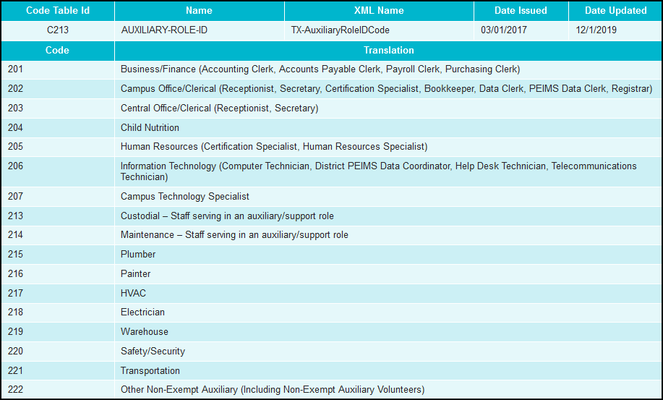

STAFF EXTENSION

Staff Reported with ROLE-ID from C021 Code Table:

Professional Staff
Professional staff includes all teachers, administrators, certified personnel, and others working in a professional capacity in the district. When making the determination of whether a person is an auxiliary or a professional-level employee, the district should consider whether the employee is logically grouped with the professional category (with such staff as business managers, personnel directors, teacher appraisers, instructional officers, etc.) or in the auxiliary non-professional category (with such staff as clerks, bus drivers, food service workers, secretaries, etc.). The classification of professional staff is generally based on two criteria. First, is the person performing a function described by one of the Role-IDs in code table C021, and second does the LEA classify the person to be serving in a professional capacity. If an LEA considers a staff person to be a professional, then the person must be reported with a Role ID from code table C021.

Substitute teachers are not reported as school staff unless they are considered long-term substitutes. If a teacher has quit, died, or been terminated from employment, and the district has not hired a permanent replacement, then the staff data are required for the long-term substitute who is working on the PEIMS Fall snapshot date (last Friday in October).

Contracted Professional Staff
Contracted professional staff that are hired through a private company, agency, or direct contract, are considered part of the professional staff of the district or campus and are reported with an appropriate Role ID from code table C021. This includes both instructional and non-instructional contracted professional staff.

Teacher Employed By In-District Charter Operator
A teacher employed at the in-district charter campus by an organization that has been granted a campus charter under TEC, Chapter 12, Subchapter C and is eligible for benefits under TEC, §11.174 and 11.147(b).

Professional Volunteer Staff
Volunteer staff serving the district in a professional capacity are reported with a Role ID from code table C021.

Para-professionals
Para-professionals are limited to two particular services; Educational Aides (Role ID 033) and Certified Interpreters (Role ID 036). Paraprofessional staff are not included in the auxiliary category.

Staff Reported with AUXILIARY-ROLE-ID from C213 Code Table:
Auxiliary Non-Professional Staff
Auxiliary non-professional staff include all other persons serving the LEA as an employee that do not have a specific ROLE-ID. Do not report contracted auxiliary non-professional staff.

The identification of a person as auxiliary non-professional does not depend on their educational level and/or certification status. For example, the school janitor may have a college degree, but based upon the duties that he performs, he is identified as auxiliary.

Auxiliary non-professional staff includes such employees as food service workers, cafeteria monitors, school crossing guards, security guards, clerks (such as attendance, purchasing, accounting, payroll, general office, file, mail), receptionists, secretaries, maintenance workers (bus, plant, etc.),groundskeepers, bus drivers, custodial staff, data processing key entry personnel, delivery personnel (mail, equipment, etc.), aides to the school nurse, and library aides. These are employees who do not fit the description in any Role ID code, including Role IDs 113 and 114 from code table C021. These staff members will be reported with an AUXILIARY-ROLE-ID (E1594) under the StaffEducationOrgEmploymentAssociationExtension.

Auxiliary non-professional staff does not include those employees considered to be professional-level staff in the district. Possible examples of auxiliary professional staff are computer programmers, computer operators, bookkeepers, executive assistants to administrators, or any other professional-level staff who have identifiable roles.

Staff Not Reported:

Non-Professional Volunteer Staff
Volunteer staff are only reported if the volunteer is serving the district in a professional capacity. Professional volunteer staff will be reported with a Role ID from code table C021. All other volunteer staff are not reported through the TSDS system as school staff.

For the PEIMS Fall Submission (1), each person reported through the 30040 StaffExtension Complex Type is required to have a value reported for either the

Auxiliary Role ID in the 30050 StaffEducationOrgEmploymentAssociationExtension Complex Type or/and the Role ID in the 30090 StaffResponsibilitiesExtension Complex Type.

The reporting of the correct Role ID and Auxiliary Role ID for each staff person reported through the StaffExtension Complex Type is controlled by the Object Codes reported on the 30060 PayrollExtension Complex Type. It is possible for a single staff person to have both an Auxiliary Role ID and a Role ID if the person is paid as a professional and a support person evidenced by multiple payroll entries.

Determining OBJECT-CODE from ROLE-ID or/and AUXILIARY-ROLE-ID

Staff Type Code (C181) | Role ID (C021) or  Auxiliary Role ID (C213) | Payroll Object Code (C159)
1 - Employee | Any Role ID from C021  (but generally not 033 or 036) | 6119 - Salaries or Wages-Teachers and Other Professional Personnel  6112 - Salaries or Wages for Substitute Teachers and Other Professionals
1 - Employee | Paraprofessional Role IDs:  033 – Educational Aide  036 – Certified Interpreter | 6129 - Salaries or Wages for Support Personnel  6122 - Salaries or Wages for Substitute Support Personnel  Or, for some exempt professionals:  6119 - Salaries or Wages-Teachers and Other Professional Personnel
1 - Employee | Any Auxiliary Role ID from C213 | 6129 - Salaries or Wages for Support Personnel  6122 - Salaries or Wages for Substitute Support Personnel
1 - Employee | Combination of:  Any Role ID from C021  AND  a Paraprofessional Role ID:  033 – Educational Aide  036 – Certified Interpreter | Report both  Professional Salaries/Wages:  6119 - Salaries or Wages-Teachers and Other Professional Personnel, or  6112 - Salaries or Wages for Substitute Teachers and Other Professionals  AND  Support Salaries/Wages:  6129 - Salaries or Wages for Support Personnel, or  6122 - Salaries or Wages for Substitute Support Personnel, or  6119 - Salaries or Wages-Teachers and Other Professional Personnel
1 - Employee | Combination of:  Any Role ID from C021  AND  Any Auxiliary Role ID from C213 | Report both  Professional Salaries/Wages:  6119 - Salaries or Wages-Teachers and Other Professional Personnel, or  6112 - Salaries or Wages for Substitute Teachers and Other Professionals  AND  Support Salaries/Wages:  6129 - Salaries or Wages for Support Personnel, or  6122 - Salaries or Wages for Substitute Support Personnel
3 - Contracted Professional Staff | Any Role ID from C021 | Payroll data is not reported for contracted professional staff
4 - Teacher Employed By In-District Charter Operator | Role ID 087 from C021 | Payroll data is not reported for charter partner teachers

Copyright Notice
All rights reserved: This material may not be reproduced or distributed without the express written permission of the Education Service Center Region 11.

